
University of Hertfordshire - Postgraduate Diploma in Pharmacy Practice Year 2: Core and Optional modules (15/30 credits)

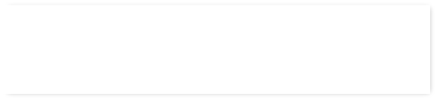
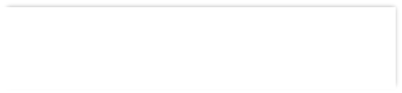




TIMETABLE 2026/27 – Programme Pathway Induction: 15th September, Cohort A (9am-11am) and Cohort B (1pm-3pm), Online via teams
Leadership, Education and Developing Others

Therapeutics of Skin Conditions

Promoting Health

Evidence Based Practice

Independent Prescribing

Service Review and Improvement
Optional modules (30 credits)




Study day 1 (on campus, 1-6pm, room 1C100 Cohort A and B)
Diabetes
Oct 21st Cohort A
Oct 22nd Cohort B

Study day 2 (on campus, 1-6pm, room 1C100 Cohort A and B)
Cardiovascular diseases Nov 18th Cohort A
Nov 19th Cohort B

Study day 3 (on campus, 1-6pm, room 1C100 Cohort A and B)
Renal and hepatic diseases
Dec 9th Cohort A Dec 10th Cohort B

Assessment dates
Portfolio submission: 1pm Jan 12th
Portfolio interview: Feb 4th/5th (online)

Clinical Patient Care 2 15 credits
(semester A to B) 7LMS2038
Study day 1 (on campus, 1-6pm, room 1C100 Cohort A and B)
Respiratory diseases Jan 26th Cohort A Jan 27th Cohort B

Study day 2 (on campus, 1-6pm, room 1C100 Cohort A and B)
Gastroenterology Feb 9th Cohort A Feb 10th Cohort B

Study day 3 (on campus, 1-6pm, room 1C100 Cohort A and B)
Neurological & psychiatric diseases March 16th Cohort A
March 17th Cohort B

Assessment dates
Case study assessment: April 20th
Reflective Patient Care Report submission: April 21st
Clinical Patient Care 3 15 credits
(semester B) 7LMS2039







Students must take One optional 30-credit module + 30 credits (Core modules above) to achieve 60 credits in Year 2

See course web page for dates

See course web page for dates
For more information contact
k.radley@herts.ac.uk

See course web page for dates

Online delivery
See course web page for semester B dates

Contact CPDHealth@herts.ac.uk to inform the team you are undertaking the IP course as an optional module on the programme
Contact email for module team: nmp@herts.ac.uk
Campus 1-6pm
Sep 30th Cohort A (room 1C102)
Oct 1st Cohort B (room F390)

Assessment dates
SI proposal: Nov 18th
Audit proposal: Dec 2nd
SI report: Feb 17th
Audit report: April 28th
Poster presentation: On campus, room J036 May 19th (1pm - 6pm)
Leadership, Education and Developing Others
(Semester B)
Therapeutics of Skin Conditions
(Semester A)
Promoting Health
(Semester A)
Evidence Based Practice
(Semester B)
Independent Prescribing
(Semester B to C)
Service Review and Improvement
(Semester A to B) 7LMS0246

