Programme pathway 2026-27

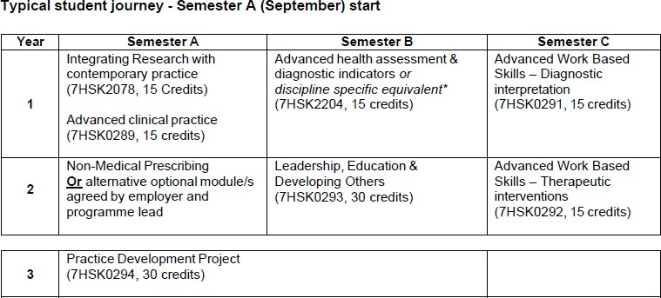

*Alternative, discipline speciﬁc equivalent modules include:
7HSK2149 Clinical Assessment and Examinations in Advancing Practice & 7HSK0327 Advanced Patient Assessment and Clinical Reasoning.

