
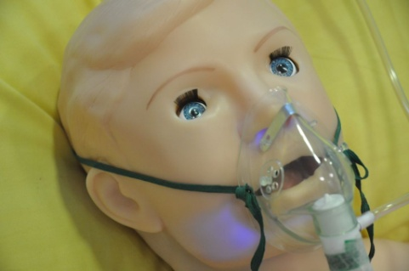
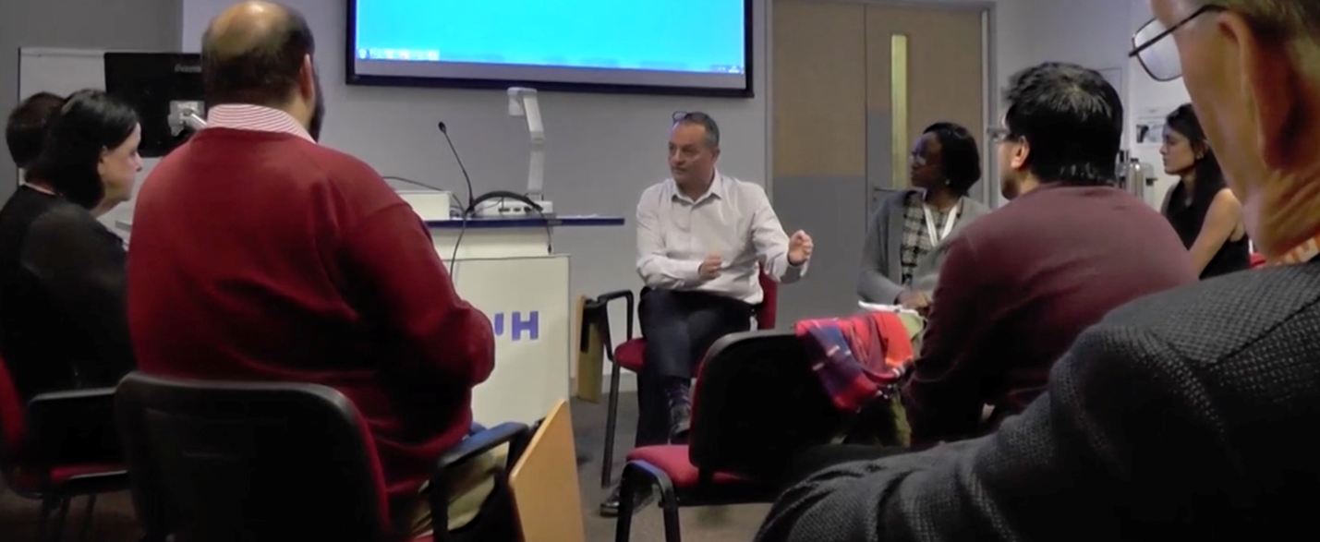
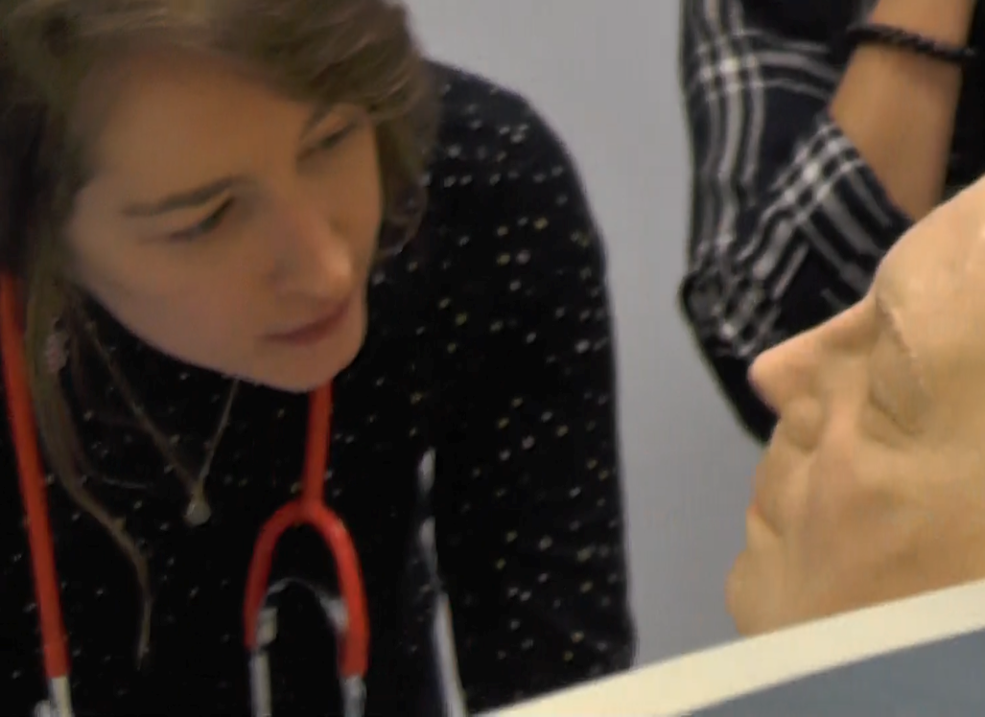
Content
Includes the following:

- Explore & analyse educational approaches towards of learning relevant to simulation training.
- Developing and writing simulation scenarios
- Creating educational safe spaces & psychological safety
- Evidence-based contemporary approaches to structured debriefing in simulation-based healthcare education
- Simulation, transfer to practice and the patient safety agenda
- Cost effectiveness and faculty development
- Simulation, and human factors/ergonomics
- Transformative simulation, i.e. using simulation in system / process design
- This module is complimented by 7LMS0164 ‘Medical Emergencies & Human Error’

Specific Entry Requirements
1st Degree or equivalent experience. Simulation education is integral to your job role.

Dates Attendance at the University is required for two four-day study blocks.
Monday September 29th – Thursday October 2nd, 2025
Monday November 24th – Thursday November 27th, 2025
(These dates are currently provisional)

Study Route This module may be studied as a standalone module or as part of a longer academic award such as an MSc, or Postgraduate Certificate in Health and Medical Simulation.

Fees Home fee status £1830

Venue F428, Clinical Simulation Centre, Ground Floor, Health Research Building, College Lane Campus.

Applications are very welcome!!
For further information on courses contact Ken Spearpoint Associate Prof in Learning and Teaching
Email k.g.spearpoint2@herts.ac.uk
To apply direct, email health@herts.ac.uk
The key module aims are to enable students to explore theories of learning relevant to the delivery of simulation based medical education. With an emphasis on evidence-based contemporary debriefing, students will be enabled to (further) develop these critical skills through real-time, practical facilitated simulation sessions within the excellent facilities at the University.

Students will be expected to design, deliver and evaluate a simulation session based on a scenario written according to the learning needs of their anticipated participants. This may involve adult, neonatal, or paediatric subjects. Students will focus upon the use of structured debriefing to enhance both technical and non-technical skills learning. The utility of transformative simulation in enhancing patient safety and its contribution to safer system design is also included in the curriculum.

Postgraduate Medicine
Health and Medical Simulation – Design and Delivery
Code: 7LMS0163, Credits: 30, Level: M

